

**INTI INTERNATIONAL COLLEGE SUBANG JAYA**

**CENTRE OF AMERICAN EDUCATION (CAE)**

**PEER ASSIGNMENT 1 (10%)**

|  |  |  |  |  |
| --- | --- | --- | --- | --- |
| Programme Name | **AMERICAN UNIVERSITY PROGRAM (AUP)** | | | |
| Module Name | **OBJECT-ORIENTED PROGRAMMING IN JAVA I** | | Module Code | **CSC200** |
| Session/Semester | **Jan 2020** |
| Module Leader Name | **K SHIVA** | | Assessment Type / Reference No. | **Peer Assign1 / Jan 2020** |
| Student Name |  | | Student Matric No. |  |
| Student Name |  | | Student Matric No. |  |
| Student Name |  | | Student Matric No. |  |
| Student’s declaration | I hereby certify that this assignment is my own work and where materials have been used from other resources, they have been properly acknowledged. I also understand I will face the possibility of failing the module if the content of this assignment are plagiarized.  Signed (1)_______________________ Date: _________________  Signed (2)_______________________ Date: _________________  Signed (3)_______________________ Date: _________________ | | | |
| Learning Outcomes (s) /  Criteria  covered | * **LOC 1**: Produce computer programs using control structures, data structures, methods, and classes. | | | |
| * **LOC 2**: Analyze object oriented programming concepts in programming problems. | | | |
| * **LOC 3:** Demonstrate information management and lifelong learning skills in developing computer program. | | | |
| Release Date | **05.02.2020** | Submission Due Date | **04.03.2020 at 10AM-12PM, A-L4-R108** | **Marks obtained** |
| Date Received |  | Student’s work assessed by / date |  |

PEER ASSIGNMENT

You are required to involve in either a group of 2 members or individually, to design **and develop a**Java application which performs the following tasks by using appropriate *comments, variable usage, program logic, I/O statements, looping structure, with proper validation, interactive and user friendly* java solution with ALL the possible output screens as your evidence

**Note: If there is an inevitable situation to be form as 2 members as a group, you are required to get prior permission from lecturer before proceed.**

**Task 1 (10%):**

Write a java program which accept **FIVE (5)** numbers from user (input) as integer type and calculate sum and average of numbers as float type.

|  |  |  |  |  |
| --- | --- | --- | --- | --- |
| Program(**10** pts) | **(Excellent)** | **(Good)** | **(Fair)** | **(Poor)** |
| Any additional creative thinking including validation (9-10) | Program executes correctly with no syntax or runtime errors (7-8) | Meet the basic requirements but acceptable (5-6) | Program executes with a minor (easily fixed error) (3-4) | Program does not execute (0-2) |
|  |  |  |  |  |
| **TOTAL** |  |  |  |  |

**Sample Outputs:**

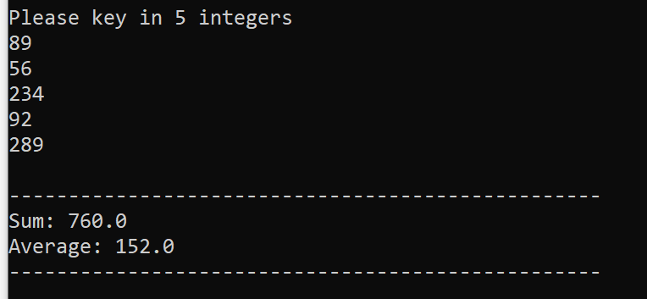

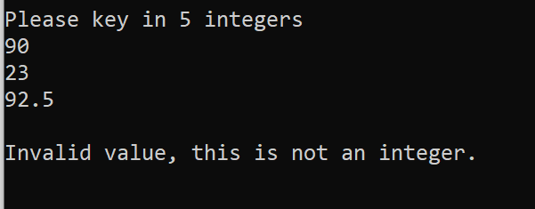

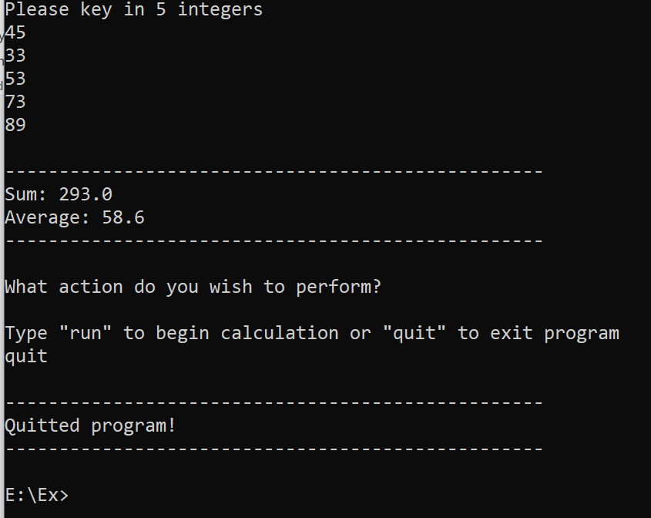

**Task 2 (20%):**

Write a java program that lets the user perform arithmetic operations on two numbers. Your program must be **menu driven**, allowing the user to select the operation (+, -, *, /) and input the numbers. Furthermore, your program must consist of following functions:

* Function **showChoice**: This function shows the options to the user and explains how to enter data.
* Functions **add**: This function accepts two numbers as arguments and displays sum value.
* Function **subtract**: This function accepts two number as arguments and displays their difference.
* Function **multiply**: This function accepts two number as arguments and displays product.
* Function **divide**: This function accepts two number as arguments and displays quotient.

**Hint: On every subsequent selection, your program to require to ask the user to continue the next selection or need to quit.**

|  |  |  |  |  |
| --- | --- | --- | --- | --- |
| Program (**20** pts) | **(Excellent)** | **(Good)** | **(Fair)** | **(Poor)** |
| Any additional creative thinking including validation (17-20) | Program executes correctly with no syntax or runtime errors (13-16) | Meet the basic requirements but acceptable (9-12) | Program executes with a minor (easily fixed error) (8-5) | Program does not execute (0-4) |
|  |  |  |  |  |
| **TOTAL** |  |  |  |  |

**Sample Outputs:**

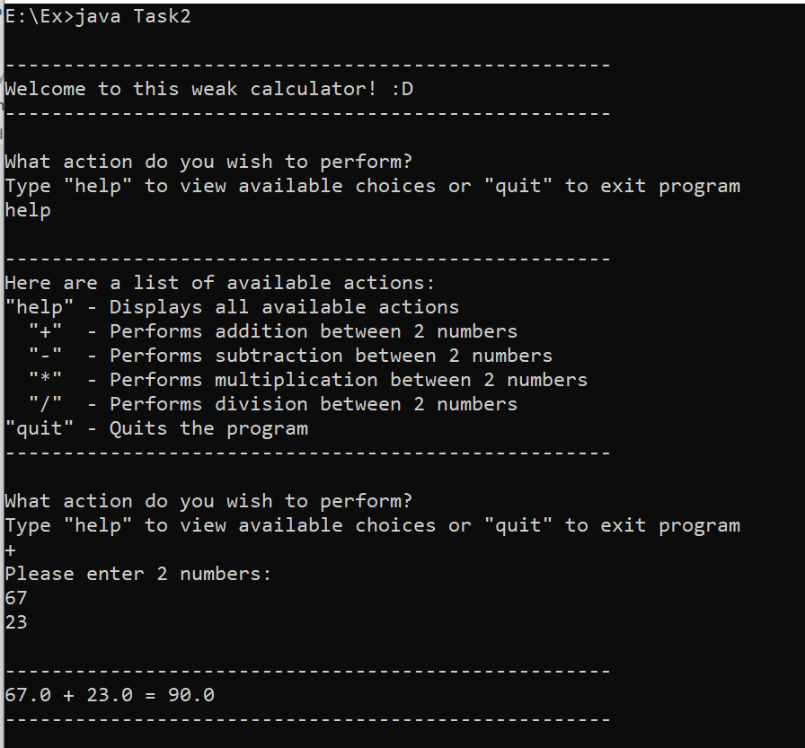

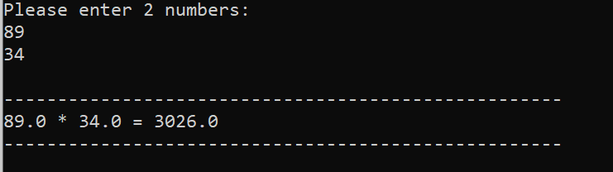

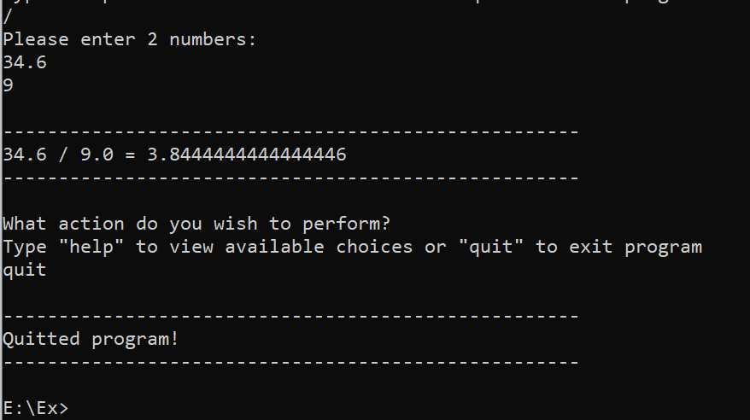

**Task 3 (50%):**

Write a **Java application** which performs the following scenarios:

1. Display an interactive design of a restaurant and welcome message screen when start running the program.
2. Prompt the user to enter a Customer name, IC/Passport, etc.,
3. List of available food items as given below and prompt the user to select any **SEVEN (7)** choices:

**1** – Fried Rice, **2** – Laksa, **3** – Chicken Chop, **4** – Kolo Mee, **5** –Seafood **6**-Spaghetti, **7**-Stop.

*Hint: you are required to include the price of the food as float type, which is your own choice.*

1. Display error message if the user enters choices other than 1 to 7.
2. For menu 2, and 5, there will be **NO** discount given, but for menu 1, 3, and 6, there will be a **5%** discount given, where by for menu 4, there will be a **10%** discount given.
3. Prompt the user to food’s selection (price must be fixed) and quantity of food purchased only if the user enters the valid choices.
4. Calculate the Overall price, discount, SST (2%), and final Total and display the **receipt** along with customer details. [final receipt must be ***interactive*** and which contains ***all the details***.
5. Required to provide all the necessary **verification** & **validation** wherever is required in task (ii) to task (vii). –

|  |  |  |  |  |
| --- | --- | --- | --- | --- |
| Program (**50** pts) | **(Excellent)** | **(Good)** | **(Fair)** | **(Poor)** |
| Design of logic, testing, verification and validation, Standards (interactive, user-friendliness), **Any additional creative thinking** (42-50) | Program is logically well designed (35-41) | Program has slight logic errors that do no significantly affect the results (34-28) | Program has significant logic errors (11-27) | Program is incorrect (0-10) |
|  |  |  |  |  |
| **TOTAL** |  |  |  |  |

**Sample Outputs:**

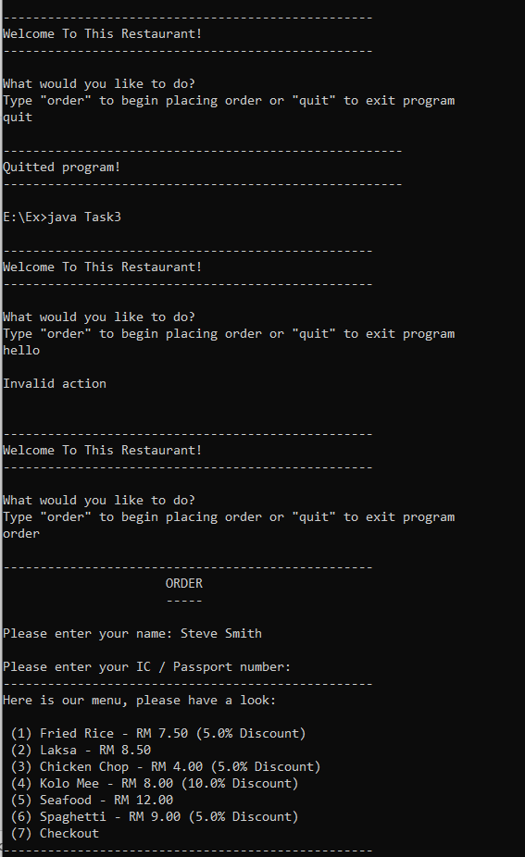

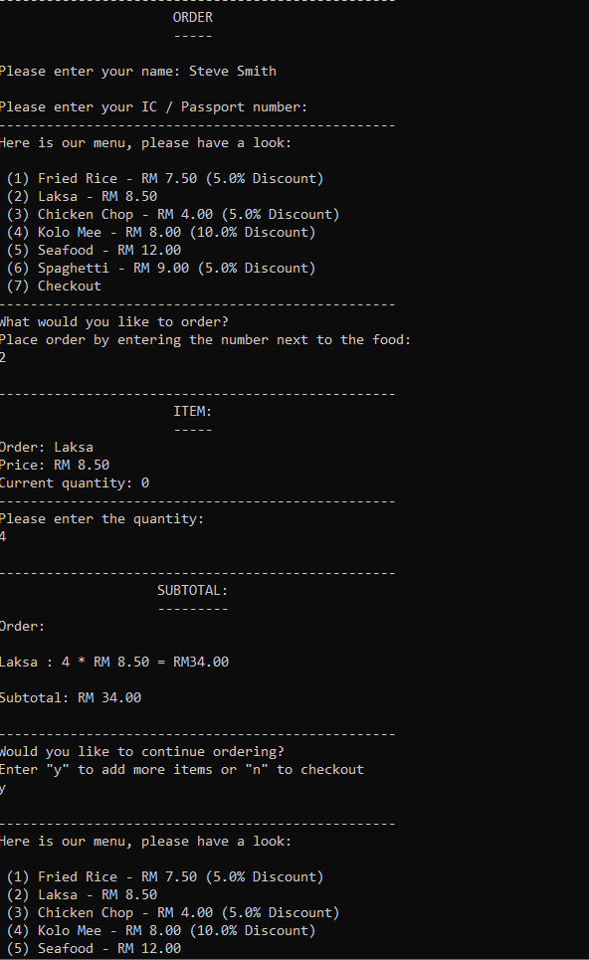

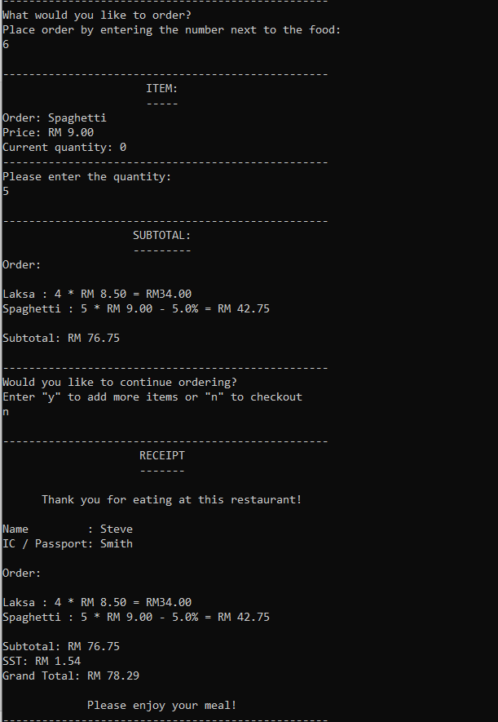

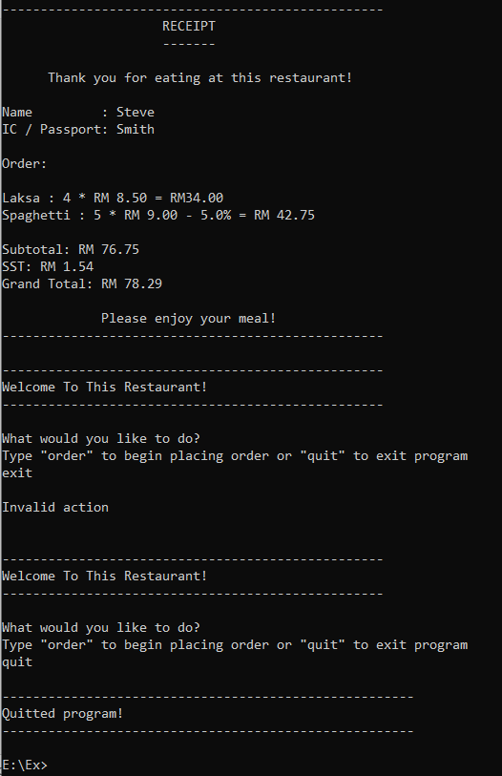

**Task 4 (20%):**

MIX, a software company provides petrol allowance for staffs that are frequently on travelling outstation. The Petrol allowance claim rate is shown in the table below.

|  |  |
| --- | --- |
| **Kilometer** | **Rate** |
| First 10 Km | RM1.80 per km |
| Next 50 Km (from 11 to 60) | RM1.50 per km |
| Next 50 Km (from 61 to 110) | RM1.30 per km |
| Beyond 111 Km | RM1.00 per km |

If the total allowance is morethan RM150.00 than an additional bonus of 5% is added as their incentive amount. Write a java application program to read the name of the staffs, the distance that has been travelled, and print out the total allowance that the staff received along with ALL the particulars (final receipt).

|  |  |  |  |  |
| --- | --- | --- | --- | --- |
| Program (**20** pts) | **(Excellent)** | **(Good)** | **(Fair)** | **(Poor)** |
| Design of logic, testing, verification and validation, standards (interactive, user-friendliness), **Any additional creative thinking** (16-20) | Program is logically well designed (15-13) | Program has slight logic errors that do no significantly affect the results (10-12) | Program has significant logic errors (9-5) | Program is incorrect (0-4) |
|  |  |  |  |  |
| **TOTAL** |  |  |  |  |

**Sample Outputs:**

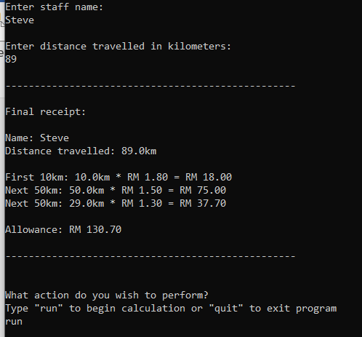

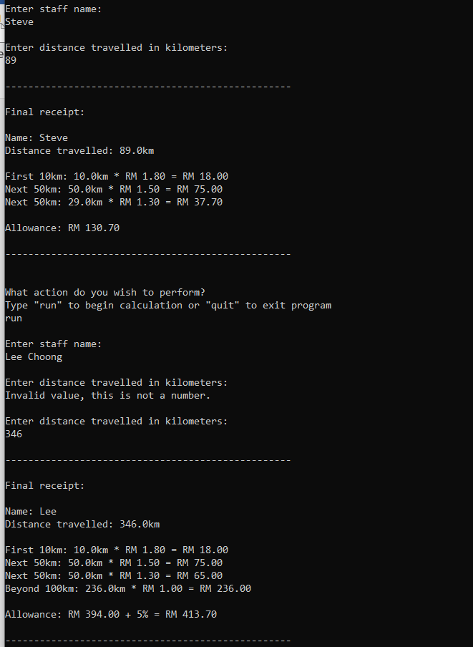

**Instructions to Students:**

During the execution of your program, the following criteria must be met:

* All classes must compile without any error & also program must not generate a runtime error. Must meet all assignment requirements.
* The assignment must produce accurate results. The program must accurately represent the **sample output** provided to you as a minimum requirement.
* Submit a **soft copy** of your work (which contains all tasks, diagrams, programs, all the possible output, etc.,) in **pen drive** to me, also upload your work in **Black Board (safeassign link)**. Submit your work to your instructor before or on published deadline & **ZERO (0)** marks for late compliance. Plagiarism (including copying from internet, book, or others works) is an academic dishonesty. Submit your work in original. **F** grade will be awarded for a plagiarized/copied work.
* ***Keep in mind -*** *Required to provide (upload in safeassign link) the required comments****, variable usage, program logic, I/O statements, looping structure, more interactive and user friendly*** with **all the possible output screens** for **task 1- task 4**. You are required to provide a proper documentation (only one copy for entire group) and **Presentation** (**Demonstration of the Java Code**)and **viva-voce.** If failed to demonstrate to your lecturer, your assignment work will become **NULL** and **VOID.**